**Overview of Web API and RESTful Services**

**Introduction**

A **Web API (Web Application Programming Interface)** is a powerful tool in modern software development that allows different applications to communicate with each other over the internet using standard protocols such as HTTP. It acts as a bridge between client applications (like web browsers, mobile apps, etc.) and server-side services or databases. Web APIs are essential for enabling cross-platform communication and integrating third-party services in web development.

**What is an API?**

An **API (Application Programming Interface)** is a set of rules that defines how different software components should interact. APIs allow developers to access functionalities of other applications or platforms without having to build everything from scratch.

In simpler terms, an API is like a **waiter** in a restaurant who takes your order (client request), communicates with the kitchen (server), and delivers your food (response). The client doesn’t need to know how the kitchen works—just what to ask for.

**What is a Web API?**

A **Web API** is an API that is accessible over the **web using HTTP protocols**. It allows applications to perform tasks such as retrieving data, submitting data, and executing operations by making HTTP requests. Common operations include:

* **GET** – Retrieve data
* **POST** – Create data
* **PUT/PATCH** – Update data
* **DELETE** – Remove data

Web APIs are frequently used to:

* Integrate with third-party services (e.g., payment gateways, maps, social media)
* Enable client-server communication
* Access backend databases

**What is a RESTful API?**

A **RESTful API** is a Web API that follows the **REST (Representational State Transfer)** architectural style. It uses standard HTTP methods and focuses on stateless communication between client and server. Each RESTful API treats data entities as **resources**, which can be accessed using URLs.

**Key Principles of REST:**

1. **Statelessness** – Each request from a client contains all necessary information.
2. **Resource-Based** – Everything is treated as a resource (e.g., /users, /products).
3. **HTTP Methods** – Uses standard verbs like GET, POST, PUT, DELETE.
4. **Uniform Interface** – A consistent way of communicating with APIs.
5. **Representation** – Resources can be represented in formats like JSON or XML.

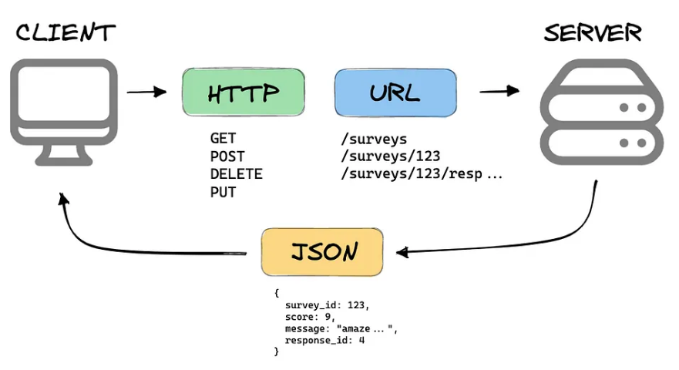

**Web API Request and Response**

**API Request:**

An API request usually contains:

* **HTTP Method (Verb)** – Specifies the action (e.g., GET, POST).
* **Headers** – Metadata such as content type and authorization.
* **Body** – Optional, for sending data (mostly in POST/PUT requests).

**API Response:**

A response from a Web API contains:

* **Status Code** – Indicates the result (e.g., 200 OK, 404 Not Found).
* **Headers** – Information about the response.
* **Body** – The actual data or message returned (often in JSON format).

**Benefits of Using Web API**

* Enables **cross-platform communication**.
* Supports **lightweight formats** like JSON and XML.
* Ideal for **mobile and web applications**.
* Promotes **modular and scalable** architecture.
* Integrates easily with **client-side frameworks** and third-party services.

**ASP.NET Core Web API**

**ASP.NET Core Web API** is a Microsoft framework designed to build high-performance, cross-platform RESTful services. It allows developers to use the same structure for building web pages and APIs using C#.

**Use Cases of Web API**

* Mobile applications accessing cloud data
* Browser-based apps interacting with backend servers
* IoT devices sending and receiving data
* Integrating services like maps, payments, notifications

**Conclusion**

Web APIs, especially those built using RESTful principles and frameworks like ASP.NET Core, are fundamental to modern software systems. They enable applications to interact seamlessly, promote reusable code, and support diverse devices and platforms. Understanding how Web APIs work is a crucial skill for any software developer today.